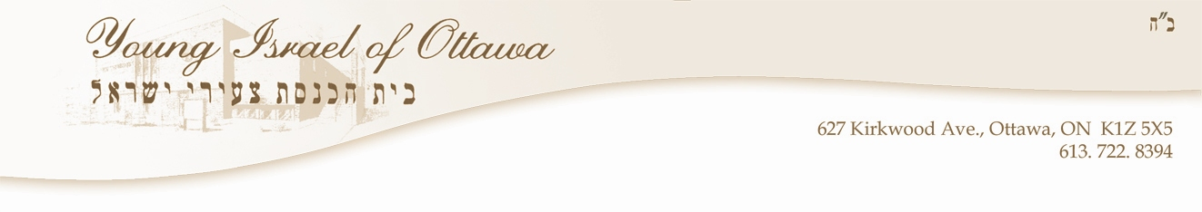

February 3, 2016
Re: Account #:10822 7406 RP0001
To Whom It May Concern:
Young Israel of Ottawa's Source Deductions payment for December 2015 paid on January 12, 2016 was supposed to be $538.90. There was also an outstanding balance of $502.58 on the account. Both balances were paid at the bank on January 12 with two separate cheques, one made out for $502.58 and one made out for $538.90. However, both payments have been posted to Source Deductions for December.
Attached is the Young Israel of Ottawa's portion of the Statement of account for current Source Deductions for December that shows how much was supposed to be posted to Deductions at Source for December as well as the balance owing of $502.58 listed at the top of the statement.
Can you please kindly move $502.58 of the payment that you received from the Young Israel of Ottawa on January 12 to cover the balance owing?
Thank you.

Page 1 of 2

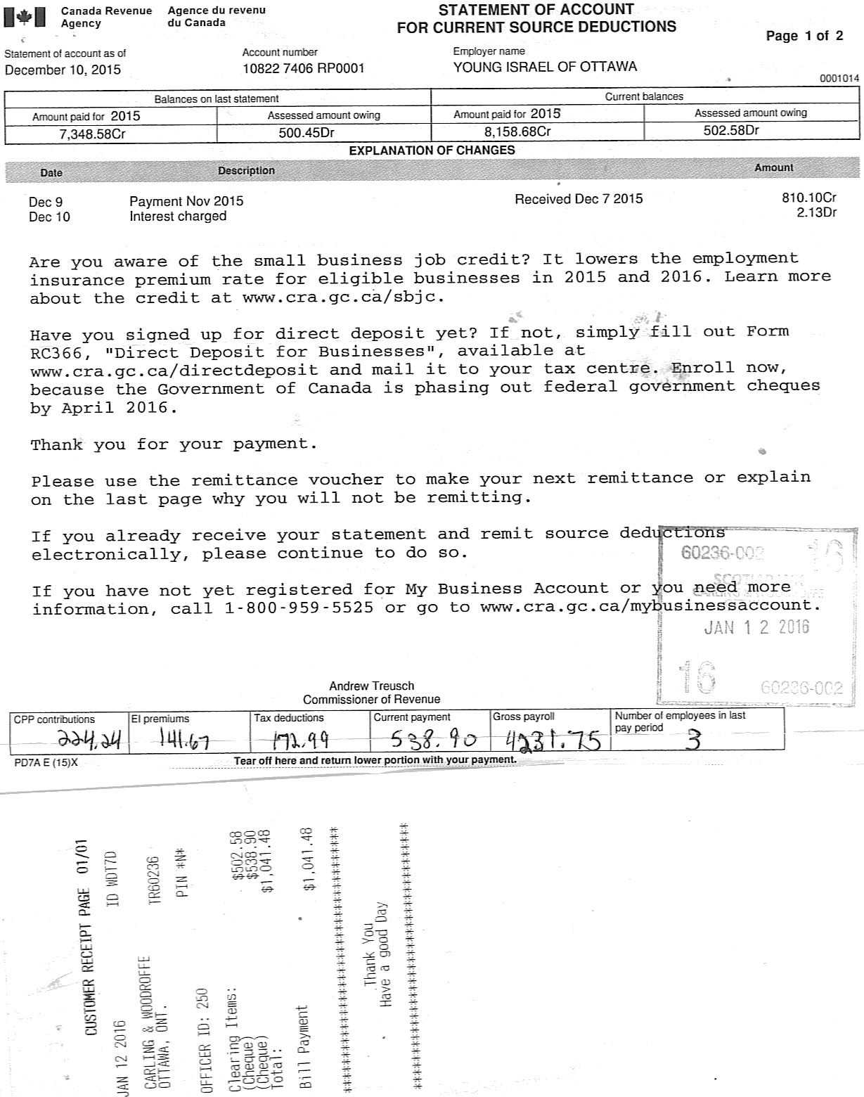

Page 2 of 2

